What is program?
Ans. A program is a set of instructions written in a programming language that a computer can understand and execute to perform a specific task or solve a problem.

Simple Explanation:
- Think of a program like a recipe.
- Just like a recipe tells a cook what steps to follow to make a dish, a program tells a computer what steps to follow to do something—like showing a message, doing a calculation, or running a gam
LAB EXERCISE: Write a simple "Hello World" program in two different programming languages of your choice. Compare the structure and syntax.

Ans. #include<stdio.h>

Void main()

{

printf(“hello world”);

}

1.Expl
THEORY EXERCISE: Explain in your own words what a program is and how it functions.

Ans. :-A program is a set of instruction written in a programming language that tells a computer what to

do.it is designed to perform specific tasks,solve problems,or control other machines and systems.

i)writing the program:A human writes the instructions using a programming language,which is

a special kind of language that computers can understand.

ii)running the program:-once the program is run,the computer follows each instruction in

order,just like following steps in a manual.

What is Programming?
Ans. Programming is the process of writing instructions (called code) that a computer can follow to perform specific tasks.
It’s like teaching a computer how to do something by giving it a step-by-step guide using a special language (such as Python, C++, Java, etc.).

THEORY EXERCISE: What are the key steps involved in the programming process?
Types of Programming Languages

Ans. Key Steps in the Programming Process:
i)understanding the problem:-before writing any code,you need to clearly understand what the
program is supposed to do .this includes:
identifying the inputs and outputs
ii) debugging:-if there are mistakes ,this step involves finding and fixing them:
syntax errors
logic errors

Types of Programming Languages
Ans. 1.abstraction level
i)high-level language:
closer to human language.
hides hardware details.
easier to read,write,and maintain.
ii)low-level language:
closer to machine language.provides little or no abstraction.
requires understanding of hardware.
2.ease of use
i)high-level language:
simple syntax,more like english.
suitable for beginners.
ii)low-level language:
complex and detailed syntax.
requires technical knowledge of the system.

World Wide Web (WWW)

What is the World Wide Web?
The World Wide Web (WWW or just "the Web") is a system of websites and web pages that you access through the internet using a web browser like Chrome, Firefox, or Safari.
- Invented by Tim Berners-Lee in 1989.
- It uses technologies like:
  - HTML (HyperText Markup Language) – to structure web pages
  - HTTP (HyperText Transfer Protocol) – to request and transfer data
  - URLs (Uniform Resource Locators) – to identify each webpage
🧠 In short: The Web is the content (pages, videos, images) you see when you're using the internet.

How the Internet Works (Simplified)
The internet is a global network of computers and servers that are all connected and can communicate.

🔄 Step-by-Step: How it Works
- You open a browser and type a website URL (like www.google.com).
- DNS (Domain Name System) translates that name into an IP address (like 142.250.64.78) so the computer knows where to go.
- Your computer sends a request to that server using HTTP or HTTPS.
- The web server receives the request and sends back the requested web page or data.
- Your browser displays the web page for you.

Components Involved:
- Client: Your computer or phone
- Server: The computer hosting the website
- Router: Sends data to the right places
- ISP (Internet Service Provider): Connects you to the internet
- Protocols: Like HTTP, TCP/IP, which define how data moves

🧠 Analogy:
Think of the Internet as a highway system and the Web as the restaurants and stores you visit using that highway.
The browser is your car, and the DNS is like a map that tells you where each place is.

LAB EXERCISE: Research and create a diagram of how data is transmitted from a client to a server over the internet.
ANS.
Step-by-Step Breakdown:
1.Client Sends Request You enter a URL in your browser. The browser forms an HTTP/HTTPS request and sends it.
2.Router & Modem Forward the Data The request is sent to your modem/router, which prepares it for the Internet by assigning local IP info and forwarding it to your ISP.
3.ISP Routes the Packet Your Internet Service Provider routes the request toward the correct destination via network infrastructure.
4.DNS Resolution If the request uses a domain (e.g., openai.com), a DNS server translates that into an IP address of the destination server.
5.Internet Backbone Transmission The request travels through the Internet Backbone — a global system of high-speed networks and routers — using TCP/IP protocols.
6.Server Receives the Request The target server receives the data. Its web server (like Nginx or Apache) handles the request and generates a response (e.g., HTML, JSON).
7.Response Travels Back The server sends a response through the same path (in reverse), and your browser displays the result.

THEORY EXERCISE: Describe the roles of the client and server in web communication.
ANS.
---->CLIENT:- the client is usually the web browser or any application used by a information from the internet
user to request
sends requests:when you visit a website,your browser sends a request to the server asking for
data.
display results:once it receives the response,it processes and displays the content for the user.
examples:chrome requesting google.com,a mobile app pulling updates from a cloud service.
---->SERVER:-a server is a computer system that stores website files and responds to requests from
clients.
recevies requests:it waits for incoming requets from clients.
handles logic:in dynamic websites,servers run back-end logic.

Network Layers on Client and Server
LAB EXERCISE: Design a simple HTTP client-server communication in any language.
ANS.
—>Here’s a simple HTTP client-server communication example using Python with its built-in libraries:

● http.server for the server # server.py
● from http.server import BaseHTTPRequestHandler, HTTPServer
●
● class SimpleHandler(BaseHTTPRequestHandler):
● def do_GET(self):
● # Set response status code
● self.send_response(200)
● # Set headers
● self.send_header('Content-type', 'text/plain')
● self.end_headers()
● # Write response body
● self.wfile.write(b'Hello from the server!')
●
● if __name__ == "__main__":
● server_address = ('localhost', 8080)
● httpd = HTTPServer(server_address, SimpleHandler)
● print("Server running at http://localhost:8080/")
● httpd.serve_forever()
http.client for the client
# client.py
import http.client
conn = http.client.HTTPConnection("localhost", 8080)
conn.request("GET", "/")
# Get response
response = conn.getresponse()
print("Status:", response.status)
print("Response:", response.read().decode())
conn.close()

THEORY EXERCISE: Explain the function of the TCP/IP model and its layers.
ANS.
---->function:-the tcp/ip model enables reliable,end to end communication over interconnected
networks.it standardizes communication so different systems and networks can communicate
efficiently,regardless of underlyinghard hardware or software.---->application layer:-
supports application protocols.
handles user interface and communication services.
Client and Servers
THEORY EXERCISE: Explain Client Server Communication
Types of Internet Connections
ANS.
i)client sends a request to the server for data or services.
ii)server recevies the request,processes it,and prepares a response.
iii)server sends a response back to the client.
LAB EXERCISE: Research different types of internet connections (e.g., broadband, fiber, satellite) and list their pros and cons.
ANS. 1)broadband (dsl or cable )
Pros cons

Widely available | Speeds can vary by location
Faster than dial-up | Cable speeds may drop during peak hours
Supports streaming & gaming | DSL is slower than cable/fiber
Affordable options | Shared bandwidth in neighborhoods

2)fiber optic internet
Pros cons
Extremely fast speeds (up to 10 Gbps) | Limited availability in rural areas
Reliable with low latency | Installation can be costly
Symmetrical upload/download | Requires new infrastructure

Ideal for heavy usage, streaming, cloud work

THEORY EXERCISE: How does broadband differ from fiber-optic internet?
Ans.
---->broadband:-broadband is a general term for high-speed internet that is always on.it includes several
types internet technologies,such as:
dsl(digital subscriber line)-uses telephone lines
cable-uses coaxial tv cables
---->fiber-optic internet uses light signals transmitted through glass or plastic fibers to deliver data.its
known for being extremely fast and reliable.
Protocols
LAB EXERCISE: Simulate HTTP and FTP requests using command line tools (e.g., curl).
Ans.
i)Basic HTTP GET Request
curl http://example.com
ii)HTTP GET with Headers
curl -H "Accept: application/json" http://example.com/api/data
3. HTTP POST Request

curl -X POST -d "username=admin&password=1234" http://example.com/login

THEORY EXERCISE: What are the differences between HTTP and HTTPS protocols?
Ans.
--->http:-http=hyper text transfer protocol.
it is the protocol used by web browsers and server to communicate and transfer data over the
internet.
url strats with: http://
examples: http://example.com---->https:-https=hyper text transfer protocol sercure.
it is http with encryption.using a protocol called ssl/tls to protect data.
url starts with:https://
examples :https://example.com
Application Security
LAB EXERCISE: Identify and explain three common application security vulnerabilities. Suggest possible solutions.
Ans.
1.SQL Injection (SQLi)
What it is:
A vulnerability where attackers insert malicious SQL code into a query, potentially giving them access to or control over the database.

THEORY EXERCISE: What is the role of encryption in securing applications?
Ans.
---->encryption is a core technology used to protect data by transforming it into a form that
unauthorized users cannot understand.in applications,encryption plays a critical role in securing both
data at rest and data in transit.
i)confidrntiality:-ensure that only authorized users can read sensitive data.
examples:-passwords,credit card numbers.
ii)data intergrity:-prevents unauthorized modification of data.
if data is altered during transmission or storage.

Software Applications and Its Types

LAB EXERCISE: Identify and classify 5 applications you use daily as either system software or application software.
Ans.
Application | Type | Explanation
Google Chrome | Application Software | Used to browse the internet; runs on top of the OS to serve user needs.
Microsoft Word | Application Software | Word processor for writing documents; not essential for running the system.
Windows 10 / macOS | System Software | Operating system that manages hardware and runs application programs.
Antivirus Software | System Software | Protects system from malware and viruses; works closely with the OS.
Spotify / YouTube | Application Software | Used to stream music or videos; directly serves user entertainment needs.

THEORY EXERCISE: What is the difference between system software and application software?
Ans. 1.system software

Feature | Details
Purpose | Manages and controls computer hardware so other software can function.
User Interaction | Works mostly in the background; not directly used for specific user tasks.
Examples | Operating Systems (Windows, Linux), Device Drivers, Utilities, BIOS
Dependency | Needed for the system to operate; supports application software

2,application software

Feature | Details
Purpose | Designed for users to perform specific tasks or solve particular problems.
User Interaction | Directly interacted with by users to accomplish work or entertainment.
Examples | Microsoft Word, Google Chrome, WhatsApp, Photoshop
Dependency | Depends on system software to run.

Software Architecture

LAB EXERCISE: Design a basic three-tier software architecture diagram for a web application.
Ans.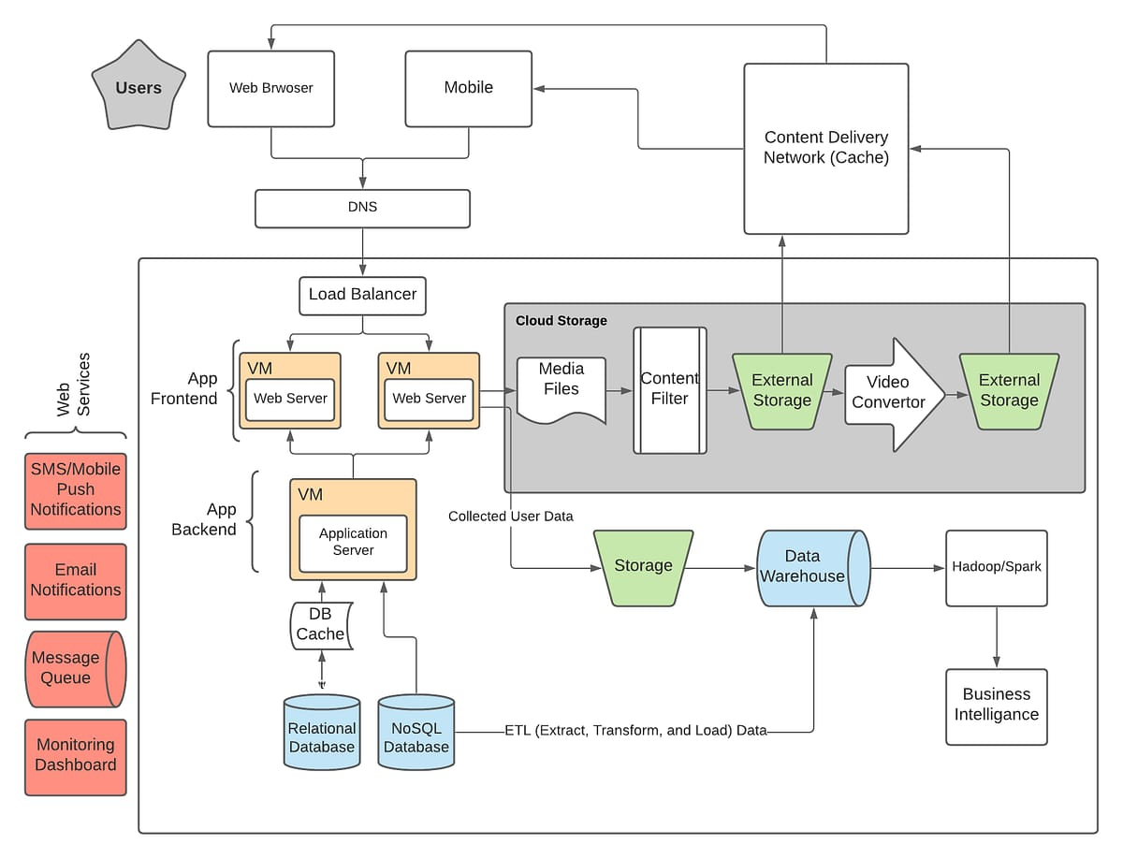

THEORY EXERCISE: What is the significance of modularity in software architecture?
Ans.
1. Significance of Modularity in Software Architecture
.Improved Maintainability

● Changes in one module can be made without affecting others.
● Easier to fix bugs or update features in isolated parts of the system.
2.Reusability
● Modules can be reused across different projects or parts of the application.
● Saves time and effort in future development.

Layers in Software Architecture

LAB EXERCISE: Create a case study on the functionality of the presentation, business logic, and data access layers of a given software system.
Ans.
Case Study: Online Food Delivery System
System Overview:
The system allows users to:
● Browse restaurants and food items
● Place and track orders
● Make payments
● View order history

It is built using a three-tier architecture:

1. Presentation Layer
2. Business Logic Layer
3. Data Access Layer

THEORY EXERCISE: Why are layers important in software architecture?
Ans.
1. Separation of Concerns
● Each layer handles a distinct responsibility: ○ Presentation Layer: User interface
○ Business Logic Layer: Application rules and workflows
○ Data Access Layer: Interacts with databases

● This makes the system easier to understand and manage.

Software Environments
LAB EXERCISE: Explore different types of software environments (development, testing, production). Set up a basic environment in a virtual machine.
Ans.
Part 1: Exploring Types of Software Environments
In software development, environments represent separate setups where applications are built, tested, and deployed. Each serves a specific purpose.
1. Development Environment (Dev)
Where developers write, build, and debug code. Includes IDEs, compilers, local servers, and mock data. Not optimized for performance or security. Example Tools: VS Code, Node.js, Python, Git, Docker
2.Testing Environment (QA/Staging)
Used for testing code before it goes live. Often simulates real-world data and conditions. Used for unit testing, integration testing, and UAT (User Acceptance Testing). Example Tools: Selenium, Postman, JUnit, Jenkins
THEORY EXERCISE: Explain the importance of a development environment in software production.
Ans.
Importance of a Development Environment in Software Production
1. Safe Space for Coding
● Developers can experiment freely without affecting the live application.
● Errors, crashes, and bugs can be identified and fixed before deployment.

2.Consistency Across Teams
● Standardized tools and versions (e.g., same compiler, libraries, OS) ensure that code behaves the same for all developers.
● Avoids "it works on my machine" issues.

Source Code

LAB EXERCISE: Write and upload your first source code file to Github.
Ans.
Step 1: Write Your First Source Code File
Let’s write a basic hello.py Python file:
# hello.py
print("Hello, GitHub!")

Step 2: Create a GitHub Account (if you don’t have one)
Visit https://github.com and sign up.

Step 3: Create a New Repository on GitHub
1. Go to your GitHub profile.
2. Click "New" (top left) or visit https://github.com/new
3. Fill in:
○ Repository name: hello-world
○ Description: (optional) My first source code upload
○ Keep it Public or Private as you prefer

4. Click Create repository

Step 4: Upload Your File to GitHub Option A: Using the Web Interface
1. In your new repository, click "Add file" > "Upload files"
2. Drag and drop hello.py, or click "Choose your files"
3. Scroll down, write a commit message (e.g., “Add hello.py”)
4. Click "Commit changes"

THEORY EXERCISE: What is the difference between source code and machine code?
Ans.
1. Source Code Feature | Description
Definition | Human-readable instructions written in a programming language
Written by | Developers and programmers
Languages | Python, Java, C++, JavaScript, etc.
Readable | Easy for humans to read, write, and modify
Example | print("Hello, World!")

Needs | Feature |  | Description
Definition |  | Low-level code that a computer’s processor can execute directly
Written by |  | Generated by compilers/interpreters (not usually by humans)
Languages |  | Binary (0s and 1s), or hexadecimal representations
Readable |  | Not human-readable or easy to understand
Example |  | 10110000 01100001 (binary)
Purpose |  | Controls the actual operations on the hardware

Github and Introductions

LAB EXERCISE: Create a Github repository and document how to commit and push code changes.
Ans.
Step 1: Create a GitHub Repository
1. Go to https://github.com and log in.
2. Click "New" or go directly to https://github.com/new.
3. Fill in:
○ Repository name (e.g., my-first-repo)
○ Optional: Description
○ Choose Public or Private

4. Click Create repository

Step 2: Set Up Git Locally
Ensure Git is installed:
Run git --version in your terminal.
If not installed, download from https://git-scm.com/downloads
Create a Project Folder Locally
mkdir my-first-repo
cd my-first-repo
Create a simple file:
bashecho 'print("Hello, GitHub!")' > hello.py

THEORY EXERCISE: Why is version control important in software development?
Ans.
1. Tracks Changes Over Time
● Records every change made to the codebase.
● Lets you view what changed, when, and by whom.
● Enables you to revert to previous versions if something breaks.

Example: If a new update causes a bug, you can roll back to a working version.
2. Supports Collaboration
● Multiple developers can work on the same project without overwriting each other’s changes.
● Handles merging and resolving code conflicts.

Example: While one developer works on the login feature, another can build the search bar.
3. Safe Experimentation
● You can create branches to develop new features or fix bugs without affecting the main codebase.
● Once tested, changes can be merged into the main project.

Example: Create a feature/signup-page branch, test it, and then merge into main.

Summary table Benefit | Why It Matters
Change Tracking | Know what changed and when
Collaboration | Multiple people can work on code together
Branching | Safely test new features or fixes
Rollback | Easily revert to stable versions
Accountability | Know who made each change

Student Account in Github

LAB EXERCISE: Create a student account on Github and collaborate on a small project with a classmate.
Ans.
Windows 10 / 11 | Operating System
macOS | Operating System (Apple devices)
Linux (Ubuntu) | Open-source Operating System
Android / iOS | Mobile Operating Systems
Device Drivers | Help OS interact with hardware like printers
BIOS / UEFI | Boot system that initializes hardware

THEORY EXERCISE: What are the benefits of using Github for students?
Ans.
Top Benefits of Using GitHub for Students

Types of Software

LAB EXERCISE: Create a list of software you use regularly and classify them into the following categories: system, application, and utility software.
Ans.
1. Learn Real-World Skills
● Gain hands-on experience with Git, the industry-standard version control system.
● Practice using branches, pull requests, and commits, just like professional developers.
● Build teamwork and project collaboration skills.

2. Create a Professional Portfolio
● Showcase your projects publicly for potential employers or internships.
● Demonstrates your skills, coding style, and growth over time.
● Your GitHub profile becomes your developer resume.

3. Collaborate on Projects
● Work with classmates on group assignments or open-source contributions.
● Use GitHub Issues, Discussions, and Project Boards to plan and track progress.
● Avoid code conflicts using pull requests and code reviews.

4. Access the GitHub Student Developer Pack
● FREE access to premium tools and resources, including: ○ GitHub Pro (private repositories, more features)
○ JetBrains IDEs (IntelliJ, PyCharm, etc.)
○ Canva Pro (graphic design)
○ Replit Hacker Plan, Namecheap domain, MongoDB Atlas, and more 🔗 Apply: education.github.com/pack

5. Explore and Contribute to Open Source

● Discover how real-world software is built and maintained.
● Contribute bug fixes, documentation, or new features to public projects.
● Learn from reading others’ code and project structures.
6. Track Your Learning Progress
● View your history of commits and repositories over time.
● Reflect on how your skills have improved.
● Get feedback through pull requests and discussions.

7. Boost Your Career Readiness
● Many employers check GitHub profiles to assess a candidate's technical skills.
● Active contributions and projects help you stand out in applications and interviews.
THEORY EXERCISE: What are the differences between open-source and proprietary software?
Ans.
Open-Source vs Proprietary Software Feature | Open-Source Software | Proprietary Software
Source Code Access | ✅ Source code is available to the public | ❌ Source code is closed and protected by the company
Ownership | Community or individual contributors | Owned and controlled by a company or developer
Usage Rights | Users can freely use, modify, and distribute | Users have limited rights defined by license agreements
Cost | Often free or donation-based | Usually paid (one-time, subscription, or license fee)

Customization | Highly customizable — users can alter the code | Not customizable without vendor permission
Support | Community forums, documentation | Official vendor support (may be paid)
Security | Transparent code enables faster detection of bugs | Hidden code; only vendor can fix issues
Examples | Linux, Firefox, LibreOffice, VLC | Windows, Microsoft Office, Adobe Photoshop, macOS
Updates | Frequent, community-driven or by maintainers | Managed and released by the company

GIT and GITHUB Training

LAB EXERCISE: Follow a GIT tutorial to practice cloning, branching, and merging repositories.
Ans.
Prerequisites
● Install Git from https://git-scm.com/downloads
● Create a GitHub account if you haven’t already: https://github.com

Step-by-Step Git Tutorial
Step 1: Create a GitHub Repository
1. Go to https://github.com/new
2. Name it: git-practice
3. Check "Initialize with a README"
4. Click Create repository

Step 2: Clone the Repository to Your Computer

Open a terminal or Git Bash:

bash
CopyEdit
git clone https://github.com/your-username/git-practice.git
cd git-practice

Now you have a copy of the repository on your local machine.

Step 3: Create a New Branch
bash
CopyEdit
git checkout -b feature-hello

This creates and switches to a new branch named feature-hello.

Step 4: Make Changes and Commit
Create a file:

bash
CopyEdit
echo "print('Hello from Git!')" > hello.py

Then add and commit it:
bash
CopyEdit
git add hello.py
git commit -m "Add hello.py file"

Step 5: Merge the Branch into Main

1. Switch back to the main branch:

bash
CopyEdit
git checkout main

2. Merge the feature branch:

bash
CopyEdit
git merge feature-hello

Step 6: Push the Changes to GitHub

bash
CopyEdit
git push origin main

✔️Your merged code is now on GitHub!

Step 7: (Optional) Delete the Branch

bash
CopyEdit
git branch -d feature-hello

Summary of Commands Action | Command
Clone a repo | git clone <repo-url>
Create a branch | git checkout -b <branch-name>

Switch branches | git checkout <branch-name>
Stage changes | git add <file>
Commit changes | git commit -m "Your message"
Merge a branch | git merge <branch-name>
Push to GitHub | git push origin <branch-name>
Delete branch locally | git branch -d <branch-name>

THEORY EXERCISE: How does GIT improve collaboration in a software development team?
Ans.
1. Enables Team Collaboration on Code
● Multiple developers can work on the same project at the same time, without interfering with each other's work.
● Changes are tracked by commits, and developers can merge their work together seamlessly.

Example: One developer can build a login feature while another improves the user dashboard—without code clashes.
2. Branching for Feature Development
● Git lets each team member create branches to work on individual tasks or features.
● These branches are independent of the main code, so bugs or experiments won’t affect production.

Use Case: feature/payment-system, bugfix/login-issue, etc.

3. Version History and Rollback
● Every change is recorded with a message, author, and timestamp.
● If something breaks, the team can revert to a previous working version.

4. Conflict Resolution and Merging
● When multiple developers edit the same file, Git helps identify and resolve conflicts before merging changes.
● This avoids overwriting someone else’s work accidentally.

5. Clear Communication Through Commit Messages
● Git commits act like a logbook of development progress, helping team members understand what was changed and why.
● Promotes transparency and accountability in teams.

6. Code Review and Feedback
● Platforms like GitHub and GitLab allow pull requests, where teammates can review, comment on, and approve code before it’s merged.
● Encourages quality control and knowledge sharing.

7. Supports Remote and Global Teams
● Git works both online and offline, and teams can collaborate from anywhere in the world.

● Remote teams can push, pull, and sync changes using platforms like GitHub, GitLab, or Bitbucket.

Application Software

LAB EXERCISE: Write a report on the various types of application software and how they improve productivity.
Ans. Introduction
Application software refers to programs designed to help users perform specific tasks or functions on a computer or digital device. Unlike system software, which manages the hardware and basic functions of a computer, application software focuses on enabling users to achieve particular objectives such as creating documents, managing data, or editing media. The right application software significantly boosts productivity by simplifying tasks, automating processes, and enhancing collaboration.

Types of Application Software and Their Productivity Benefits
- Word Processing Software

○ Examples: Microsoft Word, Google Docs, LibreOffice Writer

○ Purpose: Creating, editing, formatting, and printing text documents.

○ Productivity Benefits:

■ Automates formatting and grammar checks

■ Allows real-time collaboration and document sharing

■ Offers templates to save time on repetitive tasks

- Spreadsheet Software

○ Examples: Microsoft Excel, Google Sheets, LibreOffice Calc

○ Purpose: Data analysis, calculations, budgeting, and financial planning.

○ Productivity Benefits:

■ Automates complex calculations with formulas

■ Provides data visualization tools (charts, graphs)

■ Supports large-scale data management and analysis

- Presentation Software

  - Examples: Microsoft PowerPoint, Google Slides, Prezi

○ Purpose: Creating slideshows for teaching, training, or business presentations.

○ Productivity Benefits:

■ Simplifies the creation of professional visuals

■ Enhances communication with multimedia support

■ Encourages better preparation and clearer messaging

- Database Management Software (DBMS)

  - Examples: Microsoft Access, MySQL, Oracle Database

○ Purpose: Organizing, storing, and managing large volumes of data.

○ Productivity Benefits:

■ Improves data accuracy and reduces redundancy

■ Enables fast data retrieval and reporting

■ Enhances data security and access control

- Graphic Design and Multimedia Software

  - Examples: Adobe Photoshop, Canva, CorelDRAW

○ Purpose: Creating and editing images, videos, and animations.

○ Productivity Benefits:

■ Streamlines content creation with ready-to-use assets

■ Facilitates branding and marketing through visual storytelling

■ Enables creative expression in professional settings

- Communication and Collaboration Software

  - Examples: Microsoft Teams, Zoom, Slack, Google Meet

○ Purpose: Facilitating remote communication and teamwork.

○ Productivity Benefits:

■ Supports instant messaging and video conferencing

■ Enables real-time document sharing and co-authoring

■ Enhances team coordination and project tracking

- Project Management Software

  - Examples: Trello, Asana, Monday.com, Jira

○ Purpose: Planning, tracking, and managing projects and tasks.

○ Productivity Benefits:

■ Helps set goals, deadlines, and responsibilities

■ Provides visual tools (Kanban boards, Gantt charts) for tracking progress

■ Improves accountability and workflow efficiency

- Web Browsers

  - Examples: Google Chrome, Mozilla Firefox, Microsoft Edge

○ Purpose: Accessing the internet and web-based applications.

○ Productivity Benefits:

■ Provides access to online resources and tools

■ Enables use of cloud-based applications

■ Supports extensions that enhance browsing and task management

Conclusion
Application software plays a crucial role in enhancing personal and professional productivity. Whether it’s managing data, communicating with a team, or creating content, each type of application software serves a specific purpose that contributes to efficiency and effectiveness. As technology continues to evolve, the integration and advancement of application software will further empower users to accomplish more in less time.

THEORY EXERCISE: What is the role of application software in businesses?

Ans.

Role of Application Software in Businesses
Application software plays a vital role in modern businesses by supporting daily operations, enhancing efficiency, and enabling strategic decision-making. It helps employees perform specific tasks more quickly and accurately, streamlines business processes, and improves communication within and outside the organization.

Software Development Process

LAB EXERCISE: Create a flowchart representing the Software Development Life Cycle (SDLC).
Ans.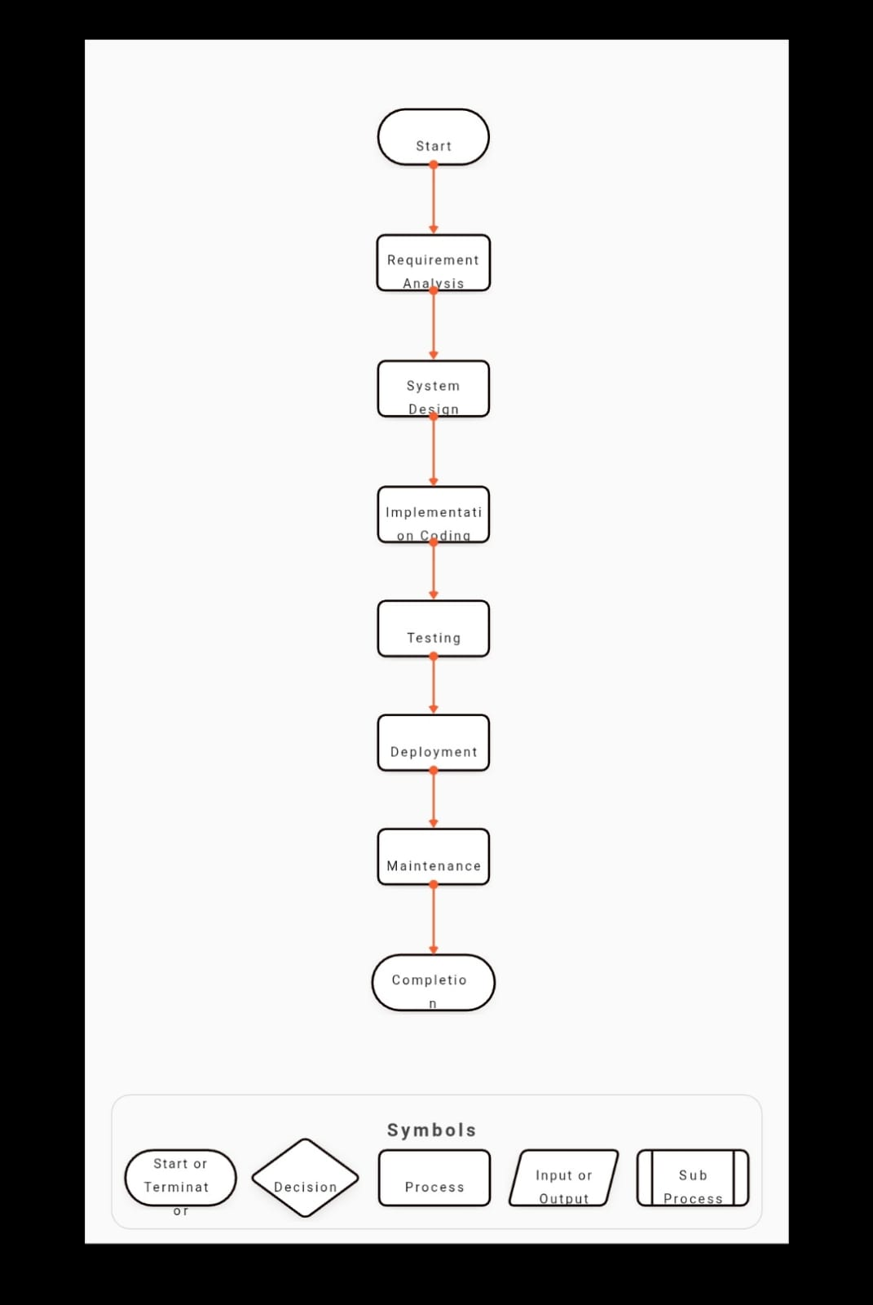

Flowchart Description
- Requirement Analysis

  - Gather and analyze the business and user needs.

- System Design

  - Design system architecture, database structure, and user interfaces.

- Implementation (Coding)

  - Developers write code based on the design specifications.

- Testing

  - Test the software to find and fix bugs and verify requirements are met.

- Deployment

  - Release the software to users for real-world use.

- Maintenance

Fix issues, update features, and enhance performance as needed.

THEORY EXERCISE: What are the main stages of the software development process?

Ans. Main Stages of the Software Development Process
The Software Development Life Cycle (SDLC) is a structured process that ensures high-quality software is developed systematically. It consists of several key stages, each serving a specific purpose:

1. Requirement Analysis
- Purpose: Understand what the client or user needs.

- Activities:

○ Gather requirements through interviews, surveys, or documentation.

○ Define functional and non-functional requirements.

○ Prepare a Software Requirements Specification (SRS) document.

- Outcome: Clear, documented understanding of the project’s goals and features.

2. System Design
- Purpose: Plan how the software will be built.

- Activities:

○ Create architectural designs, data flow diagrams, and UI/UX prototypes.

○ Decide on technologies, frameworks, and tools.

- Outcome: A detailed design blueprint for developers to follow.

3. Implementation (Coding)
- Purpose: Convert design into a working software product.

- Activities:

○ Write code using the chosen programming languages.

○ Follow coding standards and practices.

- Outcome: Source code that implements the required features.

4. Testing
- Purpose: Ensure the software works correctly and is bug-free.
- activites

○ Perform unit testing, integration testing, system testing, and user acceptance testing (UAT).

○ Identify and fix bugs or issues.

- Outcome: A tested and quality-assured software product.

5. Deployment
- Purpose: Make the software available to users.

- Activities:

○ Install or publish the software on servers or devices.

○ Configure settings and perform final checks.

- Outcome: Operational software available for real-world use.

6. Maintenance
- Purpose: Keep the software functional and updated.

- Activities:

○ Fix bugs reported by users.

○ Release updates and new features.

○ Adapt to changing user or business needs.

- Outcome: Improved software performance and user satisfaction over time.

Software Requirement

LAB EXERCISE: Write a requirement specification for a simple library management system.

Ans. 1. Introduction
1.1 Purpose
This document describes the functional and non-functional requirements for a simple Library Management System (LMS). The system is intended to automate the operations of a library, including book issue/return, member management, and catalog maintenance.
1.2 Scope
The LMS will manage book inventory, user registrations, issue/return transactions, and generate reports. It is designed for use by library staff and registered users (students or members).
1.3 Intended Users
- Library Administrators

- Librarians

- Registered Members

2. Overall Description
2.1 Product Perspective
The system will be a standalone web-based or desktop application with a relational database backend (e.g., MySQL or SQLite). It will have user-friendly interfaces for different user roles.
2.2 Product Functions
- Add/update/delete books and members.

- Issue and return books.

- Search and view book catalog.

- Maintain record of transactions.

- Generate simple reports.

2.3 User Classes and Characteristics
- Administrator: Manages system settings, users, and backups.

Librarian: Manages books, issues/returns, and member data.

- Member: Can view/search books and their own issued books.

3. Functional Requirements
3.1 User Management
- Admin can add, update, or delete user accounts.

- Login/logout functionality for all users.

- Password reset and role-based access control.

3.2 Book Management
- Add new books with fields: Title, Author, ISBN, Publisher, Year, Category, Copies Available.

- Edit or delete existing book records.

- Track number of copies available/issued.

3.3 Member Management
- Add new members with ID, Name, Address, Email, and Phone.

- Update or delete member records.

- View a member's issued book history.

3.4 Issue/Return Books
- Record when a book is issued or returned.

- Prevent issue if no copies are available.

- Calculate and display due dates and late fees (if any).

3.5 Search and Catalog
- Search books by title, author, or category.

- View book details and availability.

3.6 Reports
- Generate reports on:

○ Books currently issued

○ Overdue books

○ Most borrowed books

○ Member borrowing history

4. Non-Functional Requirements
4.1 Performance
- The system should respond within 3 seconds for search and issue operations.

4.2 Security
- Role-based access control.

- Encrypted passwords and secure login.

4.3 Usability
- Simple and intuitive user interface.

- Minimal training required for users.

  - Portability
Should run on Windows and Linux (if desktop), or be browser-accessible (if web-based).

  - Backup and Recovery
- Regular database backup and recovery features.

5. Assumptions and Constraints
- Only one copy of a book can be issued to a member at a time.

- Maximum of 5 books can be issued to a member.

- The system will not support digital book downloads or e-books.

6. Future Enhancements
- Barcode scanning support for faster issue/return.

- SMS/email notifications for due dates and reminders.

- Mobile app integration.

THEORY EXERCISE: Why is the requirement analysis phase critical in software development?
Ans. The requirement analysis phase is one of the most crucial stages in the Software
Development Life Cycle (SDLC). It lays the foundation for the entire project by identifying what the client or end-users need from the software. A mistake or oversight at this stage can lead to delays, increased costs, or even project failure.

Key Reasons Why Requirement Analysis Is Critical

- Establishes Clear Understanding of Client Needs
  - Prevents misunderstandings between developers and stakeholders.

  - Defines what the software should do, not how it will do it.

- Serves as the Blueprint for Development
  - Provides a detailed guide for system design, coding, and testing.

  - Ensures that developers build the right product.

- Helps Identify Scope and Boundaries
  - Clearly defines the system’s limits and functionalities.

  - Prevents scope creep (uncontrolled changes or growth in project scope).

- Reduces Risk of Cost Overruns and Delays
  - Early detection of potential challenges or conflicts.

  - Helps in accurate estimation of time, resources, and budget.

- Enhances Communication Among Stakeholders
  - Creates a common language between clients, analysts, designers, and developers.

  - Involves all key users, ensuring their needs are considered.

- Improves Quality and User Satisfaction
  - Builds software that actually solves the user’s problem.

  - Reduces the number of revisions and rework needed after deployment.

- Enables Better Testing and Validation
  - Requirements become the basis for test cases.

Helps verify that the final product meets the agreed-upon needs.

Conclusion
Requirement analysis is not just a technical activity—it's a critical communication and planning process. When done correctly, it ensures that the project starts on a solid foundation, minimizes risks, and maximizes the chances of delivering a successful, user-approved product.

Software Analysis

LAB EXERCISE: Perform a functional analysis for an online shopping system.
Ans.

Functional Analysis: Online Shopping System

Objective
To define the key functions the system must perform to enable users to browse, purchase, and manage products online efficiently and securely.

1. Functional Requirements

1.1 User Management
- User Registration: New users can create accounts with basic information (name, email, password, etc.).

- User Login/Logout: Secure authentication system.

- Profile Management: Users can update personal details and change passwords.

- Role Management: Different roles (Customer, Admin, Vendor).

1.2 Product Management
- Browse Products: Users can browse products by categories, popularity, and filters.

- Search Functionality: Users can search products using keywords.

- Product Details View: View description, price, availability, images, and reviews.

- Admin Functions: Admins/vendors can add, update, or delete products.

1.3 Shopping Cart Management
- Add to Cart: Users can add multiple products to their cart.

- Update Cart: Change quantity or remove items.

- View Cart: Review selected items before checkout.

- Persistent Cart: Cart items should remain available across sessions until purchase or removal.

1.4 Order Processing
- Checkout: Users provide shipping address, payment information, and place orders.

- Order Confirmation: Generate and send order confirmation.

- Payment Integration: Support online payment gateways (credit/debit card, UPI, wallets).

- Order Tracking: Users can view order status (Processing, Shipped, Delivered).

1.5 Inventory and Stock Management
- Inventory Updates: Automatically update stock after a successful order.

- Low Stock Alerts: Alert admin when product inventory is below threshold.

1.6 Reviews and Ratings
- Add Review: Registered users can review products they purchased.

- View Ratings: Users can view aggregated ratings and read comments.

1.7 Admin Dashboard
- Manage Users: Add, block, or delete users.

- View Reports: Sales reports, product performance, user activity.

- Manage Orders: View, update, or cancel customer orders.

- Manage Categories: Create or edit product categories.

1.8 Notifications
- Email Alerts: For registration, order confirmation, and shipping updates.

- In-App Notifications: Order updates and promotional messages.

2. System Actors
Actor Functions
Customer Register, browse, add to cart, place order, track order, review products
Admin Manage users, products, orders, generate reports
Vendor (Optional) Add/edit own products, view sales
System Handle payments, send notifications, update inventory

Conclusion
This functional analysis outlines the core modules and user interactions necessary to build an efficient online shopping platform. These features ensure the system delivers a smooth, secure, and scalable e-commerce experience for both users and administrators.

THEORY EXERCISE: What is the role of software analysis in the development process?
Ans. 1. Understanding Requirements
- Goal: Identify what the software needs to do.
- Activities: Gathering and analyzing stakeholder requirements, business rules, and constraints.
- Deliverables: Requirement specifications (e.g., SRS - Software Requirements Specification).

2. Defining Scope and Objectives
- Helps define what is in scope and out of scope for the project.
- Ensures alignment between business goals and technical efforts.

3. Feasibility Analysis
- Evaluates the technical, operational, and financial feasibility of the proposed system.
- Prevents costly rework by catching impractical or unclear requirements early.

4. Modeling and Documentation
- Uses tools like use cases, flowcharts, class diagrams, and ER diagrams to represent system behavior and structure.
- Creates a clear, shared understanding between developers, designers, and stakeholders.

5. Risk Reduction
- Identifies potential issues or risks related to requirements, such as ambiguities, conflicts, or incomplete definitions.
- Reduces chances of software failure or misalignment with user needs.

6. Basis for Design and Development
- Translates analyzed requirements into a form suitable for system design and architecture.
- Ensures that the development team builds the right system, not just builds the system right.

7. Improves Communication
- Acts as a bridge between technical teams and non-technical stakeholders.
- Ensures all parties have a mutual understanding of the system to be developed.

8. Supports Testing and Validation
- Provides a benchmark for validation — developers and testers can refer back to analysis documents to ensure requirements are met.
- Ensures traceability from requirements to final implementation and testing.

System Design

LAB EXERCISE: Design a basic system architecture for a food delivery app.
Ans. Food Delivery App – System Architecture
1.

Presentation Layer (Front-End)
Interface for users to interact with the system.
Components:
- Customer App (iOS/Android/Web)

  - Browse restaurants, order food, track delivery

- Delivery Agent App

  - Accept delivery requests, navigation

- Restaurant Dashboard

  - Manage orders, update menu

2.

Application Layer (Back-End / Business Logic)
Core logic that handles operations and processing.
Components:
- Authentication Service

  - Login/Signup, Token validation

- Order Management

  - Place, cancel, update orders

- Restaurant Management

  - Menus, working hours, availability

- Delivery Tracking

  - Real-time location updates, assignment logic

- Payment Gateway

  - Process online payments securely

- Notification System

  - SMS, push notifications for order status

3.

Data Layer (Database & Storage)
Stores and manages all data.
Databases:
- Relational DB (e.g., MySQL/PostgreSQL):

  - Users, Orders, Restaurants, Payments

- NoSQL DB (e.g., MongoDB):

  - Menu items, location-based data

- Real-Time DB (e.g., Firebase, Redis):

  - Live delivery tracking

- File Storage (e.g., AWS S3):

  - Images for food, receipts, restaurant logos

4.

Third-Party Services
External services integrated into the app.
- Payment Gateways (Razorpay, Stripe, etc.)

- Map APIs (Google Maps, Mapbox for directions)

- SMS/Email APIs (Twilio, SendGrid)

- Push Notification Services (Firebase Cloud Messaging)

● Architecture Diagram 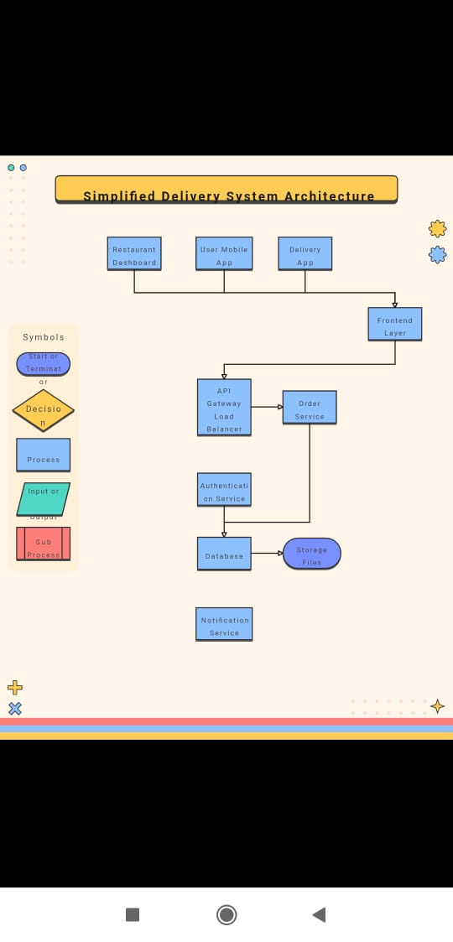
THEORY EXERCISE: What are the key elements of system design?

Ans. Key Elements of System Design
1.

Architecture Design
Defines the structure of the entire system and how its components interact.
- Monolithic vs Microservices

- Client-Server, N-Tier, or Serverless

- Cloud or On-Premises

2.

Modularity
Breaking the system into smaller, independent modules.
- Improves maintainability

- Enables parallel development

- Encourages reuse

3.

Scalability
Ensures the system can handle increased load or users.
- Horizontal Scaling (adding more machines)

- Vertical Scaling (adding more power to existing machines)

- Load balancing, caching, and sharding strategies

4.

Data Management
How the system stores, retrieves, and protects data.
- Database design (SQL or NoSQL)

- Data modeling (ER diagrams)

- Indexing and normalization

- Backup and recovery strategies

5.

Security
Protects the system from unauthorized access or attacks.
- Authentication & Authorization

- Encryption (data in transit and at rest)

- Secure API design

- Firewalls and vulnerability management

6.

Performance
Ensures fast and responsive system behavior.
- Caching (Redis, Memcached)

- CDN (for static content)

- Database optimization (queries, indexes)

7.

User Interface (UI) & User Experience (UX)
Designs how users interact with the system.
- Intuitive layouts

- Responsive design (mobile & desktop)

- Accessibility and usability

8.

Reliability & Fault Tolerance
Ensures system availability even when parts fail.
- Redundancy and replication

- Failover mechanisms

- Monitoring and alerts

9.

Maintainability
Ease of updating and fixing the system.
- Clean code and documentation

- Logging and diagnostics

- Use of version control (e.g., Git)

10.

Integration
How the system interacts with external services or components.
- REST or GraphQL APIs

- Third-party payment gateways, SMS, maps

- Webhooks or event-driven design

Software Testing

LAB EXERCISE: Develop test cases for a simple calculator program.
Ans. Assumptions
- The calculator accepts two numbers as input.

- Supports: +, -, *, /

- Handles divide-by-zero gracefully.

- Inputs are valid numbers and operators.

Sample C Code to Support These Test Cases
#include <stdio.h>

int main() { char op; double a, b;

printf("Enter first number: "); scanf("%lf", &a); printf("Enter operator (+, -, *, /): "); scanf(" %c", &op); printf("Enter second number: "); scanf("%lf", &b);

switch(op) { case '+': printf("Result: %.2lf\n", a + b); break; case '-': printf("Result: %.2lf\n", a - b); break; case '*': printf("Result: %.2lf\n", a * b); break; case '/':
if (b != 0) printf("Result: %.2lf\n", a / b); else printf("Error: Cannot divide by zero.\n"); break; default: printf("Error: Invalid operator.\n");
}

return 0;
}

THEORY EXERCISE: Why is software testing important?
Ans. Software testing is a critical phase in the software development lifecycle (SDLC). It ensures that the software works as intended, meets user requirements, and is free from defects.

1.

Detects Bugs and Errors Early
- Helps identify issues before deployment, reducing the cost and effort required to fix them.

- Prevents major system failures or crashes in production.

2.

Ensures Functionality and Accuracy
- Verifies that the software performs all intended tasks correctly under various conditions.

- Confirms that business logic and user requirements are implemented properly.

3.

Improves Software Security
- Identifies vulnerabilities such as SQL injection, data leaks, or broken authentication.

- Ensures user data protection and compliance with security standards.

4.

Boosts Performance and Reliability
- Helps ensure the system performs well under load (stress/load testing).

- Confirms system stability over time and usage.

5.

Enhances User Experience
- Ensures the software is user-friendly, intuitive, and functions smoothly.

- Prevents user frustration due to bugs, crashes, or confusing interfaces.

6.

Saves Time and Cost
- Fixing bugs in later stages is more expensive and time-consuming.

- Reduces the need for rework, support calls, and maintenance post-launch.

Maintenance

LAB EXERCISE: Document a real-world case where a software application required critical maintenance.

Ans. Case Study: WhatsApp – Critical Maintenance after Privacy Policy Update (2021)

Background
In early 2021, WhatsApp updated its privacy policy, which led to significant public backlash. Users were concerned that their data would be shared with Facebook, leading to widespread confusion and misinformation.

The Issue
- The new update prompt caused user panic, with many believing WhatsApp would start reading personal messages.

- Millions of users began migrating to alternative apps like Signal and Telegram.

- WhatsApp faced reputation damage and declining user trust.

Critical Maintenance Actions Taken
- User Communication Fix

  - WhatsApp revised the privacy policy language to make it more transparent.

○ A FAQ page was added to clarify what data is shared and what is not.

- UI Update

  - The app was updated to include in-app banners and detailed pop-ups explaining the changes more clearly.

- Deployment of Hotfixes

  - Urgent updates were rolled out across iOS and Android platforms to manage how the policy screen was shown.

- Postponement Strategy

  - The enforcement of the new policy was delayed by several months to give users more time to understand.

Outcome
- The fixes helped reduce the churn of users.

- Eventually, many users returned after clarifications.

- WhatsApp improved transparency and internal review processes for future changes.

Lesson Learned
Poor communication or misinterpreted updates can trigger a critical maintenance event. It’s not always about bugs — sometimes, user trust and perception are at stake.

THEORY EXERCISE: What types of software maintenance are there?
Development
Ans. 2.What types of software maintenance are there?
1.
Corrective Maintenance
Fixes bugs and errors found after the software has been released.
Purpose:
- Correct functional or performance issues

- Resolve user-reported problems

Examples:
- Fixing a login crash

- Correcting wrong calculation logic

2.
Adaptive Maintenance
Makes the software compatible with changes in environment or technology.
Purpose:
- Adjust to operating system or hardware upgrades

- Support new browsers, APIs, or third-party integrations

Examples:
- Modifying a web app to work with a new version of Chrome

- Updating code for compatibility with a cloud platform

3.
Perfective Maintenance
Enhances the software by adding new features or improving existing ones based on user feedback.
Purpose:
- Increase performance or usability

- Add functionality to stay competitive

Examples:
- Adding a dark mode feature

- Improving app loading speed

4.
Preventive Maintenance
Focuses on future-proofing by improving code quality or performance to avoid issues later.
Purpose:
- Reduce risk of failure

- Clean up or optimize codebase

Examples:
- Refactoring legacy code

- Updating outdated libraries or dependencies

THEORY EXERCISE: What are the key differences between web and desktop applications?
Ans. Web Applications vs Desktop Applications

Aspect | Web Applications | Desktop Applications
Installati on | No installation needed  (runs in browser) | Must be downloaded and installed on a device
Accessib  ility | Accessible from anywhere with internet | Only accessible on the installed device

Platform  Depende ncy | Cross-platform via Platform-specific (e.g., browser (Windows, Windows-only apps) macOS, Linux)
Updates | Updated centrally on the Requires manual
Updates | server | updates or auto-updater
Performa nce | Slower due to network/browser constraints | Faster due to local processing power
Storage | Data stored in cloud or server | Data stored locally on user’s device
Internet | Mostly yes | Works offline (unless network needed)
Required
Security Centralized security, but More secure offline, exposed to online but risk of local
threats vulnerabilities
Develop ment | Uses HTML, CSS,  JavaScript, server-side tech | Uses native frameworks (e.g., .NET, JavaFX, Qt)
Example  s | Gmail, Google Docs,  Facebook | MS Word, Adobe  Photoshop, VLC
Media Player
Summary:
- Web Apps: Best for real-time collaboration, wide accessibility, low maintenance for users.
- Desktop Apps: Best for heavy processing tasks, offline usage, and higher performance.

27. Web Application

THEORY EXERCISE: What are the advantages of using web applications over desktop applications?
Ans. Advantages of Web Applications Over Desktop
Applications
1.
Accessibility from Anywhere
- Can be accessed from any device with an internet connection and browser.
- Great for remote work, global teams, and users on the move.

2.
No Installation Required
- No need to download or install — just open a browser and go.
- Saves disk space and avoids installation hassles.

3.
Centralized Updates and Maintenance
- Updates are applied on the server — all users automatically get the latest version.
- No need for users to manually update their software.

4.
Cross-Platform Compatibility
- Works on all major operating systems (Windows, macOS, Linux, Android, iOS).
- Reduces development cost by building one version for all platforms.

5.
Centralized Data Storage and Backup
- User data is stored securely in the cloud.
- Easier to manage backups, disaster recovery, and data integrity.

6.
Lower Distribution and Maintenance Costs
- No packaging or shipping of software.
- Bug fixes and improvements can be rolled out instantly to all users.

7.
Easier Collaboration
- Supports real-time collaboration features (like Google Docs).
- Multiple users can work on the same data simultaneously.

8.
Responsive Design
- Web apps can be designed to work on desktops, tablets, and smartphones without separate builds.

9.
Easier Analytics & Monitoring
- Developers can track usage, performance, and errors in real-time.
- Helps improve UX based on actual user behavior.

Conclusion:
Web applications offer greater flexibility, accessibility, and ease of maintenance, making them ideal for today’s connected world.

28. Designing

THEORY EXERCISE: What role does UI/UX design play in application development?
Ans. Key Roles of UI/UX Design:
1.
Improves Usability
- Ensures that the application is easy to navigate and understand.
- Reduces learning curve for new users.
- Helps users complete tasks quickly and efficiently.

2.
Enhances User Satisfaction
- A pleasant and intuitive design leads to a positive user experience.
- Users are more likely to enjoy and continue using a well-designed app.

3.
Increases Productivity
- In business apps, good UX reduces errors and time wasted.
- Allows users to focus on their goals rather than struggling with the interface.

4.
Promotes User Retention
- Users tend to return to apps that are visually appealing, fast, and easy to use. ● Reduces bounce rates and abandonment.

5.
Supports Business Goals
- A smooth UX can lead to higher conversions, better sales, or more sign-ups.
- UI/UX decisions can directly influence business metrics.

6.
Identifies Problems Early
- User testing during UI/UX design helps uncover usability issues before development.
- Saves time and cost by avoiding major redesigns later.

7.
Establishes Brand Identity
- Consistent visuals (colors, fonts, icons) create a professional and trusted image.
- UI design reflects the app’s personality and brand.

8.
Ensures Accessibility
- UX design considers users of all abilities, including those with disabilities.
- Improves inclusivity and compliance with standards like WCAG.

29. Mobile Application

THEORY EXERCISE: What are the differences between native and hybrid mobile apps?
Ans. Native vs. Hybrid Mobile Apps

Feature | Native Apps | Hybrid Apps
Definition | Built specifically for one platform  (iOS/Android) | Built using web technologies and run inside a native shell
Languages  Used | Swift (iOS), Kotlin/Java  (Android) | HTML, CSS, JavaScript (with frameworks like Ionic, React Native)
Performance | Very high, optimized for device | Slower than native, due to WebView or bridge layer
Access to  Device APIs | Full, direct access to hardware  (camera, GPS) | Limited or needs plugins to access device features
User  Experience  (UX) | Best-in-class; matches platform  UI guidelines | May feel less “native” or inconsistent across platforms
Development  Time | Longer; separate codebases for each platform | Faster; single codebase for all platforms
Maintenance Harder; updates must be made Easier; one update affects all platforms on each platform
Cost Higher (two apps = double cost) Lower (single team, shared codebase)
Examples Instagram (originally native), Instagram Lite, Uber (some parts), Twitter
WhatsApp (early days)

30. DFD (Data Flow Diagram)

LAB EXERCISE: Create a DFD for a hospital management system.

Ans. Level 0 DFD (Context Diagram)
Purpose: Shows the system as a single process with external entities and data flow.
Entities:
- Patient
- Doctor
- Receptionist
- Admin
Process:
- Hospital Management System (Process 0) Data Stores (not shown in Level 0, introduced in Level 1) Data Flows:
- Patient submits registration, receives appointment info
- Doctor receives schedule & patient records, updates treatment
- Receptionist handles appointments and patient info
- Admin manages staff and hospital data
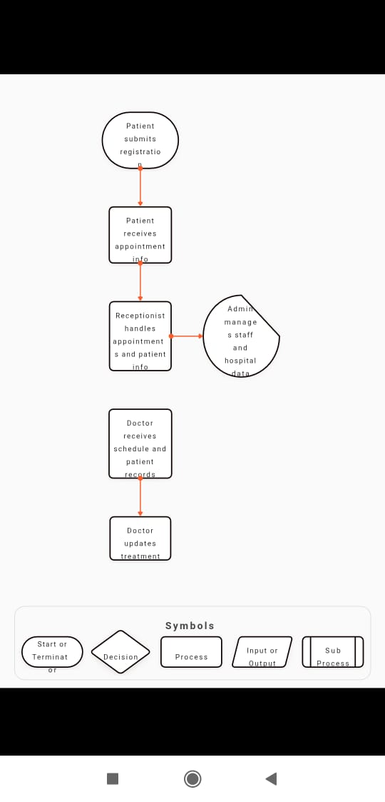

Level 1 DFD (Detailed View)
Now we break the system into sub-processes:
Processes:
- 1.0 Patient Registration
- 2.0 Appointment Scheduling
- 3.0 Medical Records Management 4. 4.0 Billing and Payments
5. 5.0 Staff & Inventory Management Data Stores:
- D1: Patient Database
- D2: Appointment Schedule
- D3: Medical Records
- D4: Billing Info
- D5: Staff Database
- D6: Inventory
External Entities:
- Patient
- Doctor
- Receptionist
- Admin
Sample Flow:
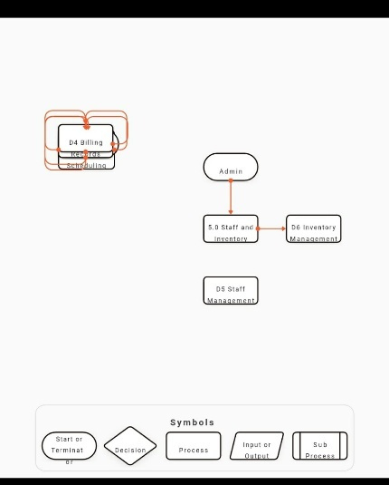

THEORY EXERCISE: What is the significance of DFDs in system analysis?
Ans. 1.

Visual Clarity
- DFDs provide a clear graphical representation of data movement.
- Helps both technical and non-technical stakeholders understand the system.

2.

Focus on Data and Processes
- Emphasizes what data is input/output, where it goes, and how it’s processed.
- Useful for identifying redundancies, bottlenecks, or inefficiencies in the system.

3.

Supports Requirement Analysis
- Helps in gathering and validating user requirements.
- Facilitates communication between analysts, developers, and users.

4.

System Decomposition
- DFDs allow a step-by-step breakdown from a high-level view (Context Diagram) to detailed components (Level
1, 2, etc.).
- Makes it easier to analyze complex systems by dividing them into smaller, manageable parts.

5.

Basis for System Design
- Forms the foundation for creating system architecture, database design, and process logic.
- Can be translated into flowcharts, pseudo-code, or actual code logic.

6.

Improves Documentation
- Serves as part of formal system documentation for future maintenance or upgrades.
- Aids in training new developers or analysts.

7.

Identifies Data Stores and Flows
- Helps pinpoint what data needs to be stored, retrieved, or processed.
- Useful for database design and integration planning.

31. Desktop Application

LAB EXERCISE: Build a simple desktop calculator application using a GUI library.

Ans. Features

- Addition, subtraction, multiplication, division
- GUI with buttons and a display
- Error handling (e.g., divide by zero)

Code: Simple Calculator with Tkinter
import tkinter as tk from tkinter import messagebox

# Function to evaluate the expression def evaluate_expression(): try:
result = eval(entry.get()) entry.delete(0, tk.END) entry.insert(tk.END, str(result)) except ZeroDivisionError:
messagebox.showerror("Error", "Cannot divide by zero") except Exception:
messagebox.showerror("Error", "Invalid expression")

# Function to add character to entry def button_click(char):
entry.insert(tk.END, char)

# Function to clear the entry def clear_entry():
entry.delete(0, tk.END)

# Create main window root = tk.Tk() root.title("Simple Calculator") root.geometry("300x400")

# Entry widget for displaying input/output entry = tk.Entry(root, font=("Arial", 20), borderwidth=2, relief="solid", justify="right") entry.pack(fill="both", padx=10, pady=10)

# Buttons layout buttons = [
('7', '8', '9', '/'),
('4', '5', '6', '*'),
('1', '2', '3', '-'),
('0', '.', '=', '+')
]

# Create buttons for row in buttons:
frame = tk.Frame(root) frame.pack(expand=True, fill="both") for char in row: if char == "=":
btn = tk.Button(frame, text=char, font=("Arial", 18), command=evaluate_expression) else: btn = tk.Button(frame, text=char, font=("Arial", 18), command=lambda ch=char:
button_click(ch)) btn.pack(side="left", expand=True, fill="both")

# Clear button clear_btn = tk.Button(root, text="Clear", font=("Arial", 16), bg="red", fg="white", command=clear_entry) clear_btn.pack(fill="both", padx=10, pady=10)

# Run the app root.mainloop()

THEORY EXERCISE: What are the pros and cons of desktop applications compared to web applications?

Ans. Desktop Applications

Pros
- Performance: Faster and more responsive; utilizes local system resources.
- Offline Access: Can work without internet.
- Better Hardware Integration: Easier to access hardware (e.g., printers, storage, GPU).
- Security: Local storage can be more secure (if the device is protected).
- User Experience: Can offer richer interfaces and smoother interactions.

Cons
- Platform Dependency: May need separate versions for Windows, macOS, Linux.
- Installation Required: Users must download and install the app.
- Maintenance: Updates must be distributed and installed manually or via updater tools.
- Limited Accessibility: Can only be accessed from the device it’s installed on.

Web Applications

Pros
- Platform Independence: Works across all devices with a browser (PC, Mac, mobile).
- No Installation: Runs directly from a browser—no setup needed.
- Centralized Updates: Developers can deploy updates instantly for all users.
- Remote Accessibility: Can be accessed from anywhere with an internet connection.
- Easier Collaboration: Real-time multi-user access (e.g., Google Docs).

Cons
1. Internet Dependent: Requires a stable connection (unless offline support is built-in). 2. Performance Limits: Heavily dependent on browser capabilities and internet speed.
- Security Risks: Exposed to web-based vulnerabilities (e.g., XSS, CSRF).
- Limited Hardware Access: Browser sandboxing restricts direct interaction with system hardware.
- Browser Compatibility: May behave differently across browsers unless carefully designed.

Summary Table

Feature Desktop Apps Web Apps
Installation Required Not required
Platform OS-dependent Platform-independent
Performance High (uses local Moderate (depends on resources) internet)
Accessibility | Device-bound | Accessible from anywhere
Updates | Manual or app-managed | Centralized by developer
Internet  Requirement | Not always needed | Usually required
Hardware Access  Flow Chart | Full (more integration) | Limited (browser restrictions)
1.Draw a flowchart representing the logic of a basic online registration system.
Main Steps in the Flowchart:
- Start
- Display Registration Form
- User Enters Information
- Validate Input Fields
○ All fields filled?
○ Valid email?
○ Password meets criteria?
- Check for Existing User (e.g., email already used?)
- If user exists → Show error & ask to try again
- If user is new → Save details to database
- Show Success Message / Confirmation
- End
32. Flow Charts
LAB EXERCISE: Draw a flowchart representing the logic of a basic online registration system.
Ans.

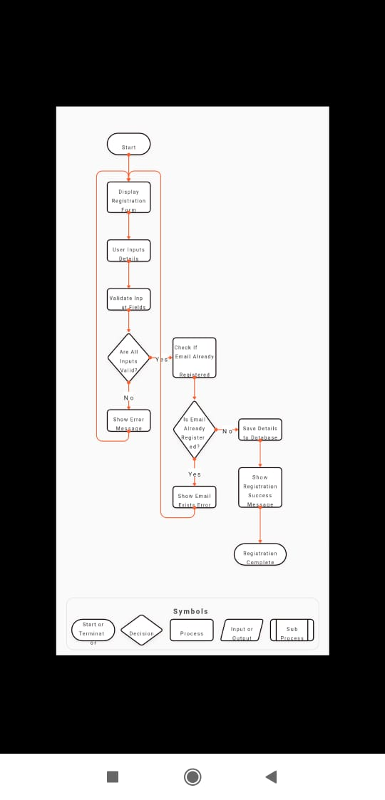
THEORY EXERCISE: How do flowcharts help in programming and system design?

Ans. . Clarify Logic Before Coding
- Flowcharts map out the step-by-step flow of a program or system.
- Help visualize decision points, loops, and operations before writing any code.
- Reduce errors caused by misunderstandings of logic.

2. Improve Communication
- Provide a common visual language that developers, designers, and non-technical stakeholders can understand.
- Makes it easier to explain how a system or function works to others (especially in teams or meetings).

3. Aid in Problem Solving and Debugging
- Help break down complex problems into manageable steps.
- Can be used to trace logic paths and identify where something might be going wrong in a program.

4. Support System Design
- Useful for designing entire systems—showing processes, data flow, and user interaction.
- Help plan control flow, interactions between modules, and how components connect.

5. Documentation
● Serve as part of system or program documentation for:
○ Future reference
○ Maintenance
○ Onboarding new developers

6. Basis for Writing Code
- Many developers write a flowchart first, then translate each box/decision into code.
- Encourages a structured approach to programming (e.g., top-down or modular design).

Example Use Cases:
- Login/authentication flows
- Input validation routines
- Algorithm design (e.g., sorting, searching)
- User registration systems
- Error-handling logic

